STATIC IP CONFIGURATION IN PC :

- By default, in the devices like PC, mobile phones, DHCP protocol is used to assign IP and other network related information including DNS Server , gateway , subnet mask etc .
- However , this type of assignment may get changed theoretically after reboot. Thus to avoid these changes, statically IP and other information can be configured.
The below image demonstrates the process of manually assigning IPv4, subnet mask , default gateway etc.

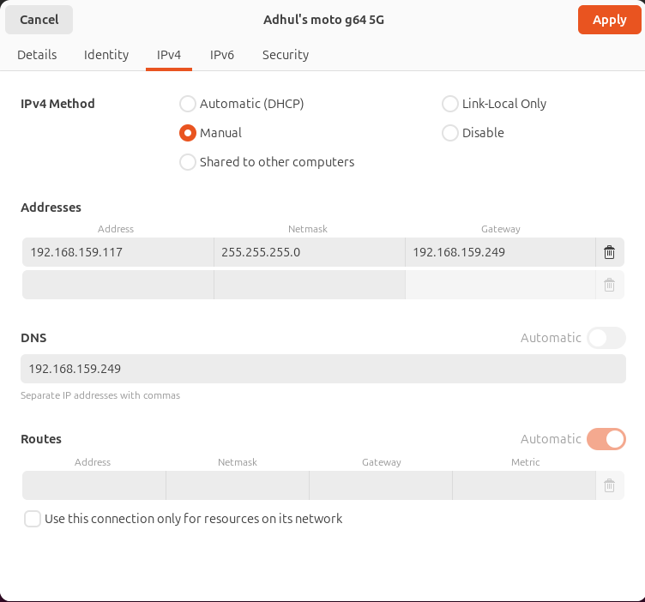

The below picture demonstrates checking the network information before and after static or manual configuration as done above. Followed by pinging the default gateway with new IP (static) to ensure the connectivity.

